MongoDB Assignment

Insert Documents
use companyDB
db.employees.insertMany([
{
emp_id: 101,
name: "Amit",
department: "IT",
skills: ["Python", "MongoDB", "Docker"],
projects: [
{ name: "HRMS", duration: 6, technologies: ["Python", "MongoDB"] },
{ name: "Ecommerce", duration: 8, technologies: ["NodeJS", "MongoDB"] }
],
salaries: [45000, 48000, 52000],
certifications: ["AWS", "Azure"]
},
{
emp_id: 102,
name: "Neha",
department: "HR",
skills: ["Communication", "Recruitment"],
projects: [
{ name: "HiringPortal", duration: 4, technologies: ["PHP", "MySQL"] }
],
salaries: [35000, 38000],
certifications: ["SHRM"]
},
{
emp_id: 103,
name: "Ravi",
department: "Finance",
skills: ["Excel", "Tally", "SQL"],
projects: [
{ name: "Accounting", duration: 10, technologies: ["SQL", "PowerBI"] }
],
salaries: [40000, 42000, 46000],
certifications: ["CPA", "CFA"]
},
{
emp_id: 104,
name: "Pooja",
department: "IT",
skills: ["Java", "Spring", "MongoDB"],
projects: [
{ name: "BankingApp", duration: 12, technologies: ["Java", "MongoDB"] },
{ name: "CRM", duration: 7, technologies: ["Spring", "MySQL"] }
],
salaries: [50000, 54000, 60000],
certifications: ["Oracle", "AWS"]
}
])
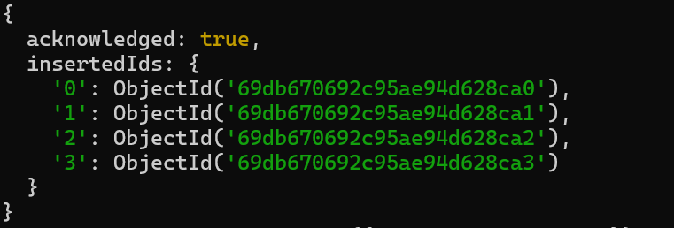

Queries

Q1. Display all employees who have MongoDB skill
db.employees.find({ skills: "MongoDB" })
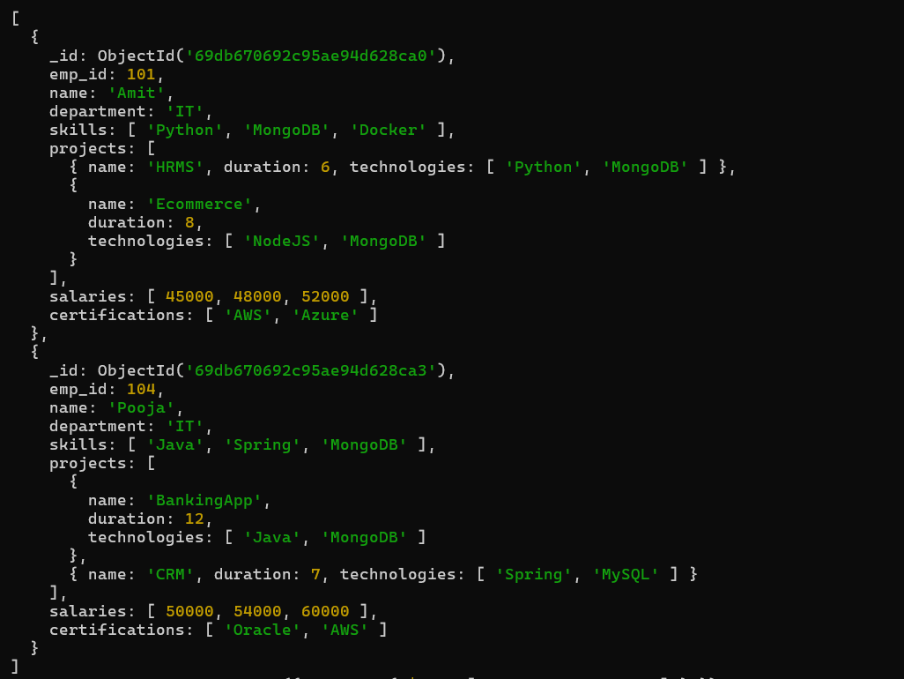

Q2. Find employees having both Python and MongoDB skills
db.employees.find({ skills: { $all: ["Python", "MongoDB"] } })
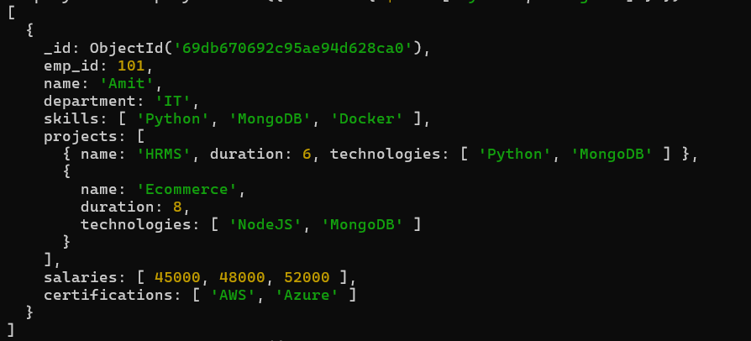

Q3. Display employees with more than 2 skills
db.employees.find({ $expr: { $gt: [{ $size: "$skills" }, 2] }})

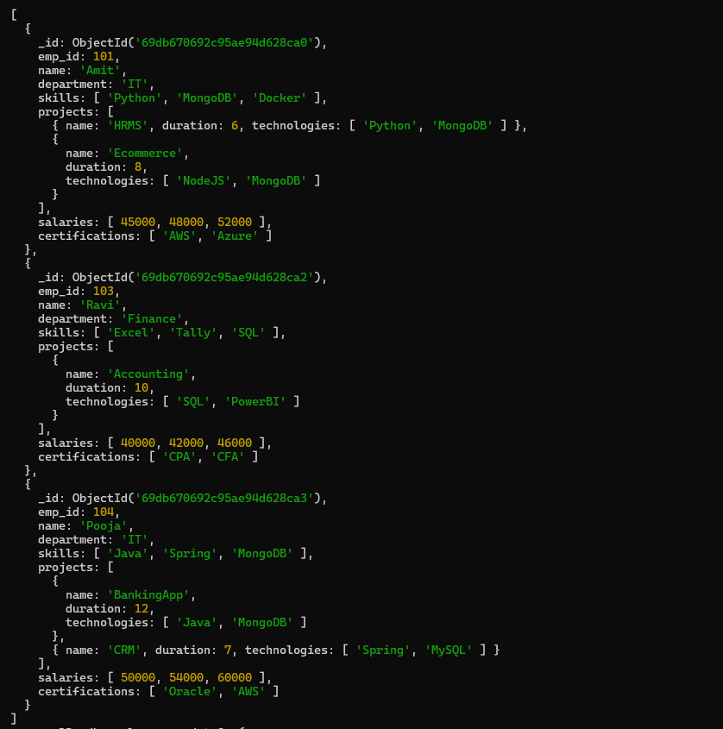

Q4. Add a new skill "Kubernetes" to Amit
db.employees.updateOne({ name: "Amit" },{ $push: { skills: "Kubernetes" } })
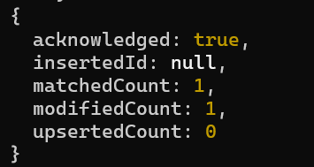

Q5. Add multiple skills to Pooja
db.employees.updateOne( { name: "Pooja" }, { $addToSet: { skills: "React" } })

db.employees.updateOne( { name: "Pooja" }, { $addToSet: { skills: "AWS" } })

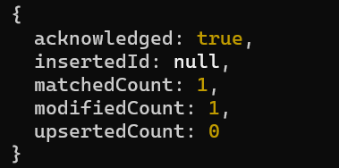
Q6. Add a certification only if not already present
db.employees.updateOne({ name: "Amit" },{ $addToSet: { certifications: "GCP" } })
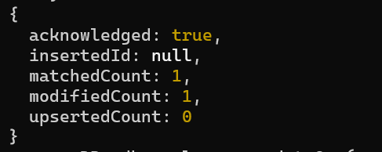

Q7. Remove "Docker" skill from Amit
db.employees.updateOne({ name: "Amit" },{ $pull: { skills: "Docker" } })
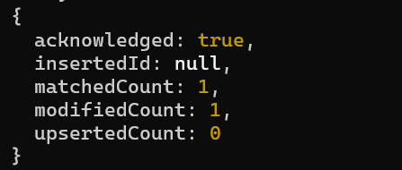
Q8. Remove multiple salaries less than 45000
db.employees.updateMany({},{ $pull: { salaries: { $lt: 45000 } } })
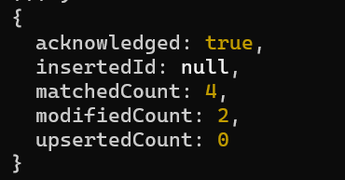

Q9. Find employees who worked on MongoDB projects
db.employees.find({ "projects.technologies": "MongoDB"})

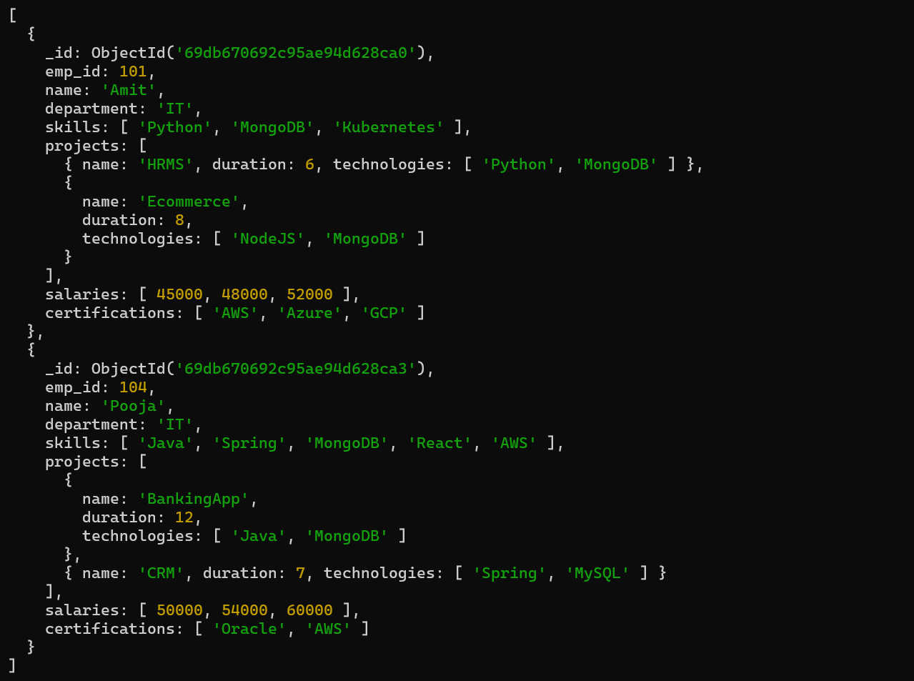
Q10. Use $elemMatch to find project duration > 6 using MongoDB
Topic not covered

Q11. Count number of projects for each employee
db.employees.aggregate([{ $project: { name: 1, totalProjects: { $size: "$projects" } }}])
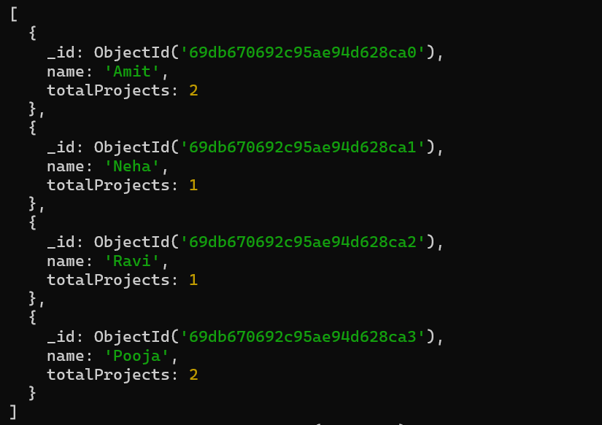

Q12. Unwind skills array
Topic not covered
Q13. List unique skills across company
Topic not covered

Q14. Find employees with salary greater than 50000
db.employees.find({ salaries: { $gt: 50000 } })
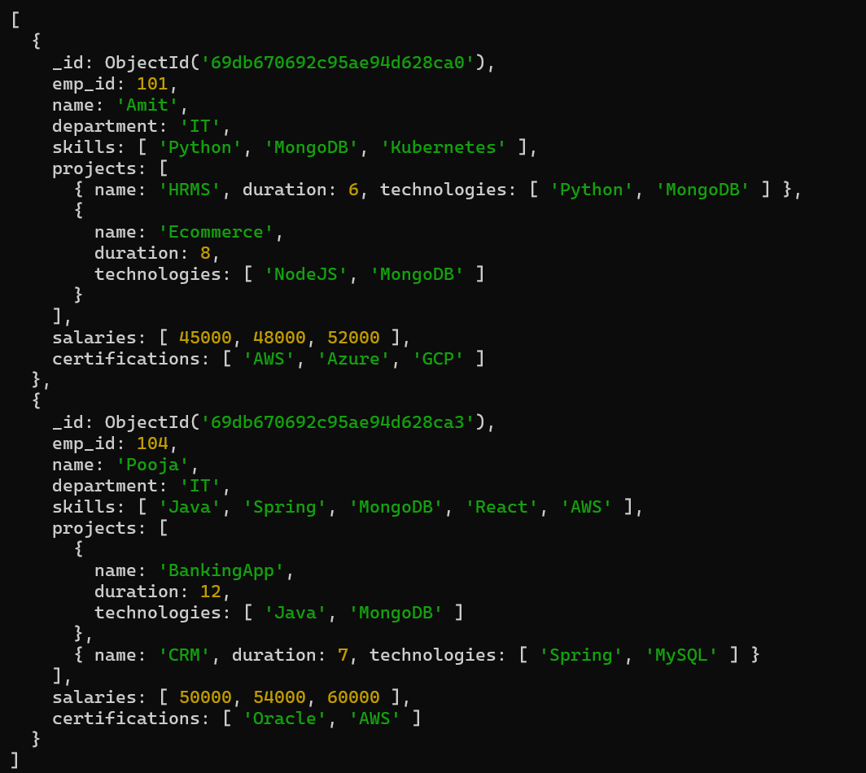

Q15. Find employees with exactly 2 certifications
db.employees.find({certifications: { $size: 2 }})
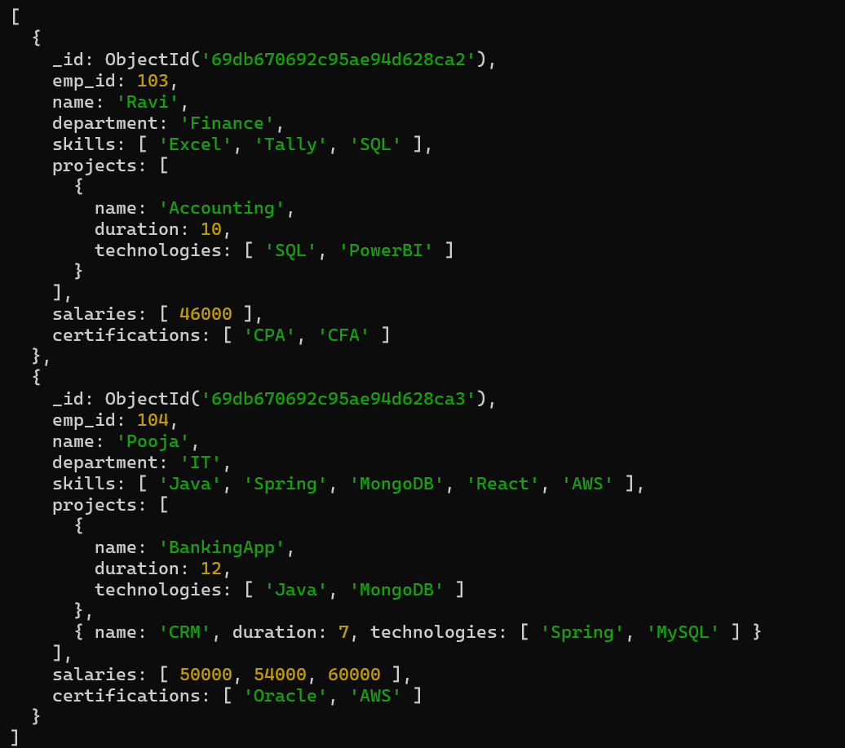

Q16. Add new project to Ravi
db.employees.updateOne({ name: "Ravi" },{ $push: { projects: { name: "BudgetSystem",duration: 5, technologies: ["SQL"] } }})
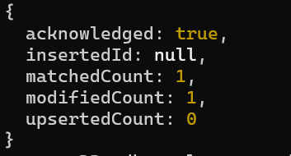

Q17. Increase all salaries by 10% (array update)
db.employees.updateMany({},{ $mul: { "salaries.$[]": 1.1 } })
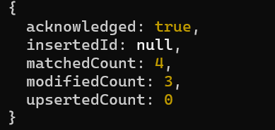

Q18. Find highest salary of each employee
db.employees.aggregate([{ $project: { name: 1, highestSalary: { $max: "$salaries" } }}])
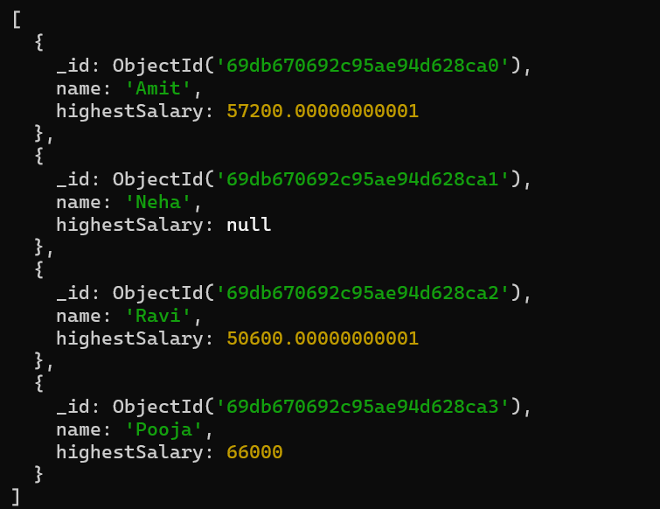

Q19. Find average salary of employees
db.employees.aggregate([{$group:{_id:null,avgsalary:{$avg:{$avg:'$salaries'}}}}])
Q20. Filter projects longer than 6 months
Topic not covered

Q21. Find employees who have any of these skills: Java or Python
db.employees.find({skills: { $in: ["Java", "Python"] }})
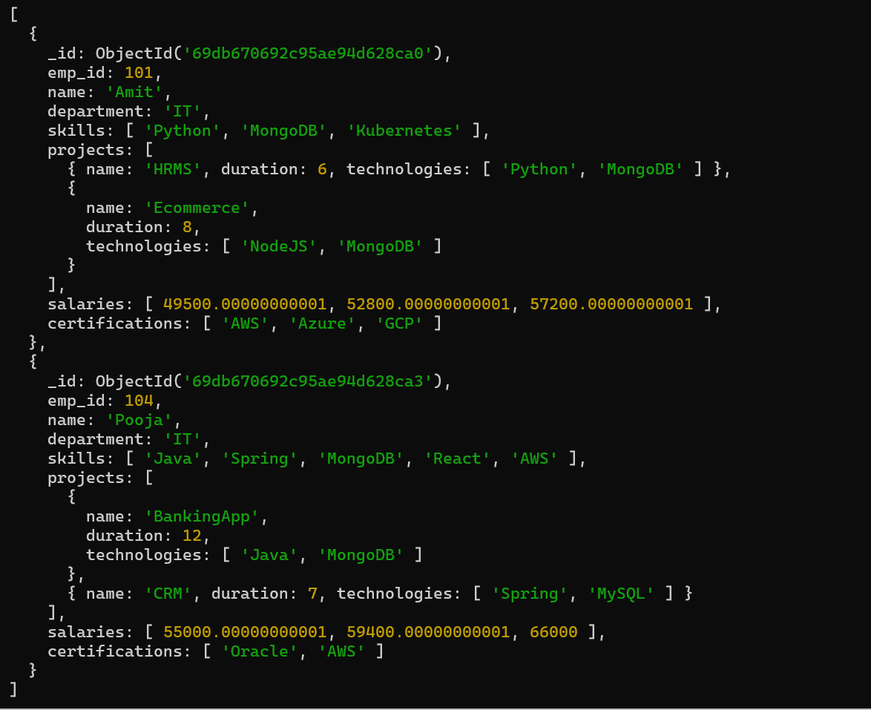

Q22. Remove last salary entry
db.employees.updateMany({},{ $pop: { salaries: 1 } })
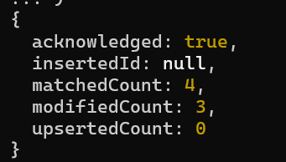

Q23. Remove first salary entry
db.employees.updateMany({},{ $pop: { salaries: -1 } })
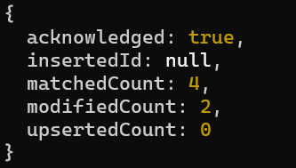

Q24. Sort salaries array
Topic not covered

Q25. Limit salaries array to last 2 entries
Topic not covered

Q26. Find total salary paid to each employee
db.employees.aggregate([{ $project: { name: 1, totalSalary: { $sum: "$salaries" } }}])
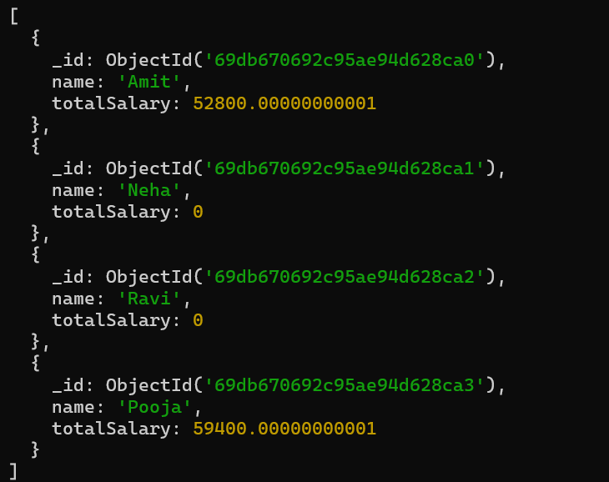

Q27. Convert skills to uppercase
Topic not covered

Q28. Find employees with more than one project
db.employees.find({ $expr: { $gt: [{ $size: "$projects" }, 1] }})
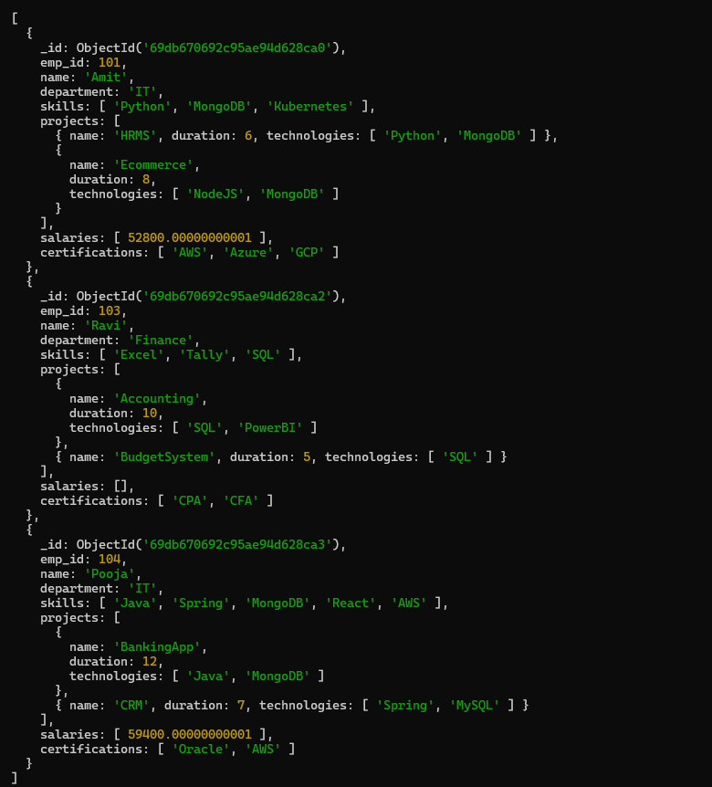

Q29. Count employees per skill
Topic not covered

Q30. Find employees whose all projects use MongoDB
Topic not covered

